Writing 1 HOUR
TASK 01:
You should spend about 20 minutes on this task.
The graph below shows population figures for India and China since the year 2000 and predicted population growth up until 2050. Summarise the information by selecting and reporting the main features, and make comparisons where relevant.
Write at least 150 words.
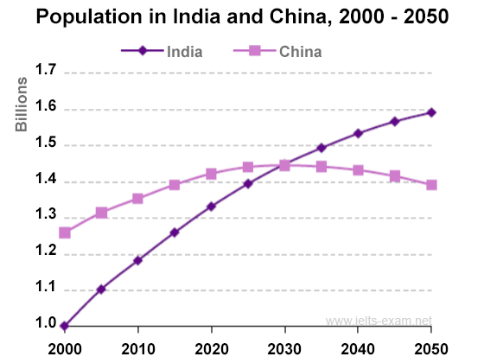
TASK 02:
You should spend about 40 minutes on this task.
Some people think that it is better to live in a small town, while others believe that living in a big city is more advantageous. Discuss both views and give your opinion.
Write at least 250 words.
Writing 1 HOUR
TASK 01:
You should spend about 20 minutes on this task.

You recently sent some documents by post, but they did not arrive at the destination.

Write a letter to the post office manager. In your letter,
- give details of the situation
- describe the documents
- say what action you want the post office to take

Write at least 150 words.
You do NOT need to write any addresses.
Begin your letter as follows:
Dear Sir or Madam,

TASK 02:
You should spend about 40 minutes on this task.
Some people think that it is better to live in a small town, while others believe that living in a big city is more advantageous. Discuss both views and give your opinion.
Write at least 250 words.

